Supporting Information

Effect of Folded and Crumpled Morphologies of Graphene Oxide Platelets on the Mechanical Performances of Polymer Nanocomposites

Jin Shang, Yuli Chen, Yanguang Zhou, Luqi Liu*, Guorui Wang, Xianglong Li, Jun Kuang, Qing Liu, Zhaohe Dai, LinjieZhi*, Zhong Zhang*

The Halpin-Tsai model can be successfully applied to predict the modulus of GO based nanocomposites. For randomly oriented GO sheets in a polymer matrix, the composite modulus E_{C} is given by
$E_{c}=[\frac{3}{8}\frac{(2L_{G}/3T_{G})η_{L}V_{G}}{1-η_{L}V_{G}}+\frac{5}{8}\frac{1+2η_{L}V_{G}}{1-η_{L}V_{G}}]E_{P}$ (1)
$η_{L}=\frac{{(E}_{G}/E_{P})-1}{E_{G}/E_{P}+2L_{G}/3T_{G}}$(2)
$η_{T}=\frac{{(E}_{G}/E_{P})-1}{E_{G}/E_{P}+2}$ (3)
where, E_{C}, E_{G}, and E_{p} represent the tensile modulus of the composites, chemically reduced GO sheet (0.25 TPa), [Ref1] and the polymer (2.72 GPa) respectively. L_{G} is the lateral size of the GO sheets, T_{G} is their thickness, and V_{G} is the volume fraction of GO in the composite.

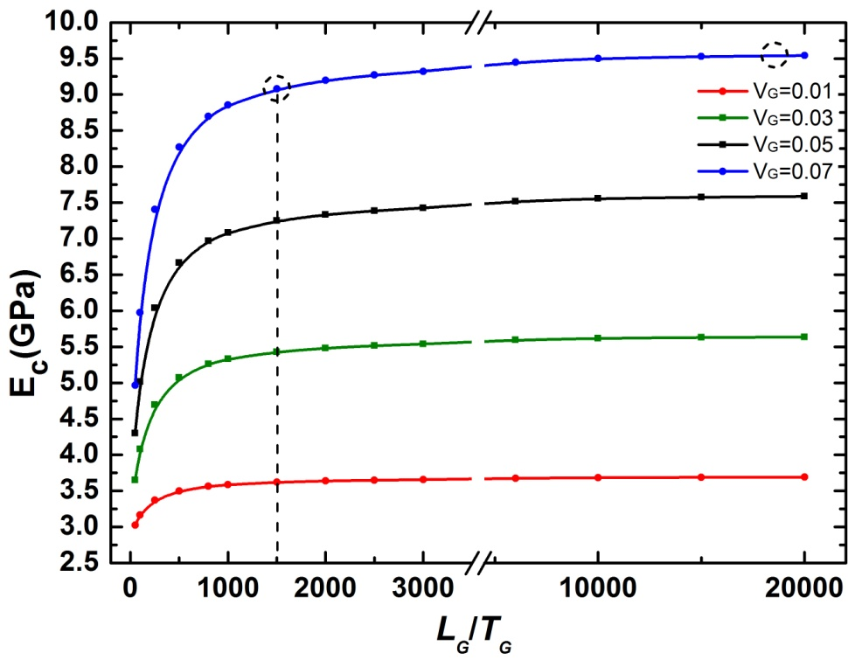
Figure S1. Young’s moduli of nanocomposites as a function of aspect ratio of GO sheets based on the Halpin–Tsai theoretical model.

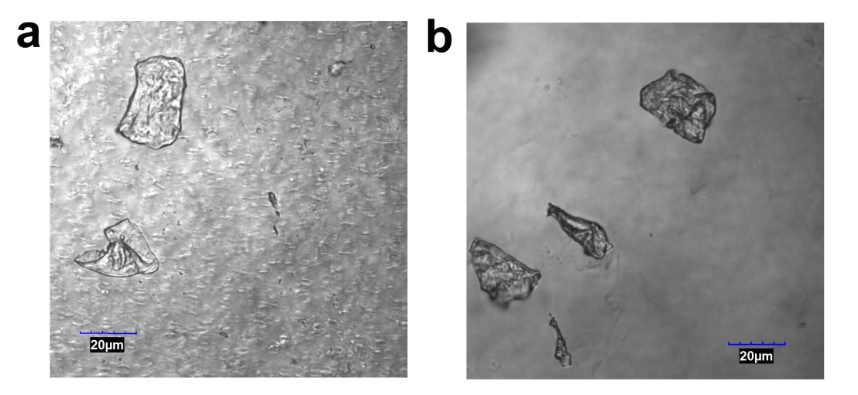
Figure S2. Images of 0.3 vol.%l-GO-based GO/PVA nanocomposites characterized by confocal laser scanning microscopy.
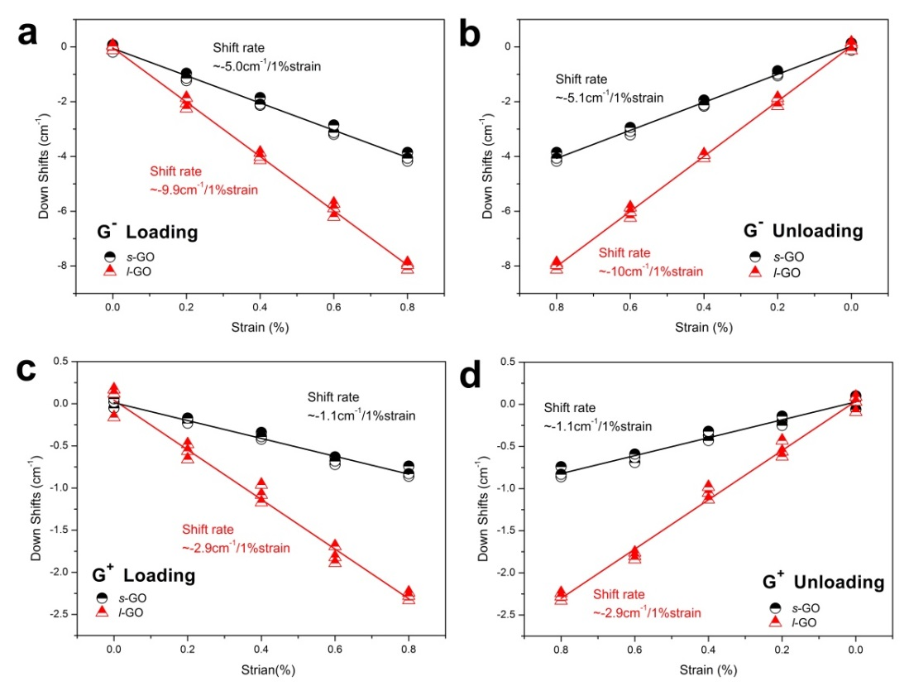
Figure S3. Shift of G-(a,b) and G+(c,d) peak positions as a function of applied strain for l- and s- GO/PVA nanocomposites under loading and unloading conditions.
REFERENCES
- Gómez-Navarro C.; Burghard M.; Kern K. Elastic Properties of Chemically Derived Single Graphene Sheets. Nano Lett. 2008, 8, 2045-2049.

